**Lab Exercise: Android.Media Audio & Video Player**

**Part 1: Audio Player**

1. Launch the **APIDemos** Android sample application and click on **Media**

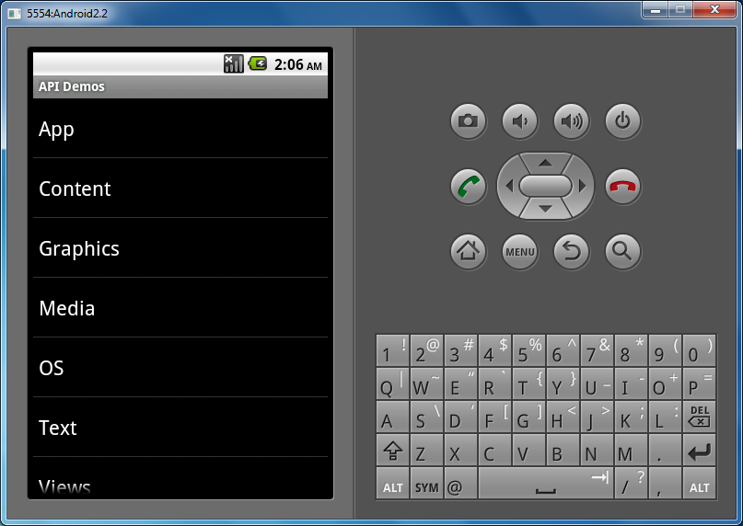

1. Click on **MediaPlayer**

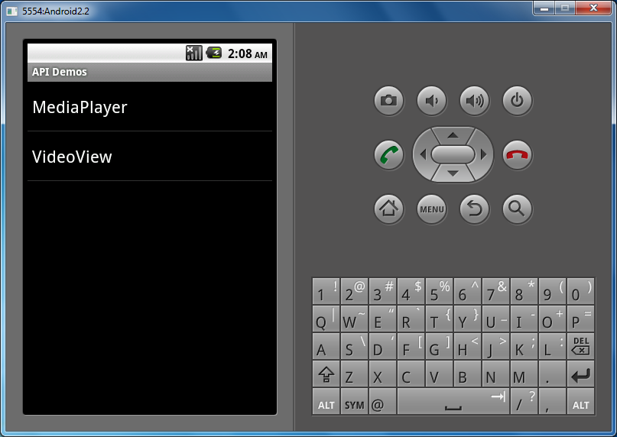

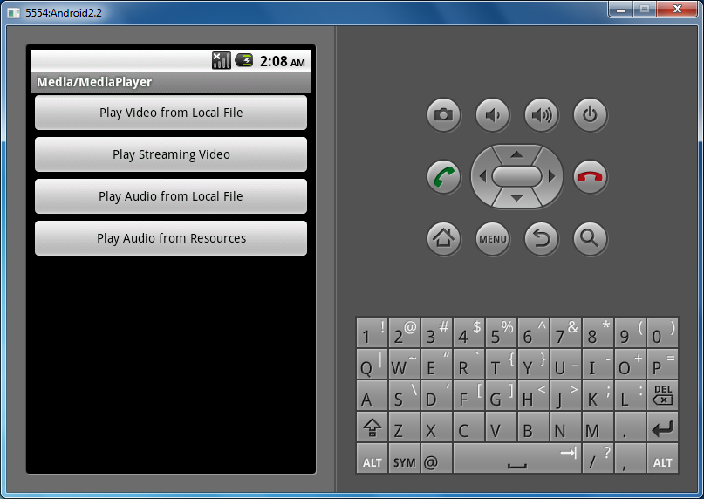

1. Without making any changes, the ‘**Play Audio from Resources**’ button should already be functional and will play some music located in the **res/raw** folder in the application. The file is called **test_cbr.mp3**.
2. To make the ‘**Play Audio from Local File**’ button functional, click on DDMS in Eclipse and select the active emulator.
3. Open **mnt** and select **sdcard**

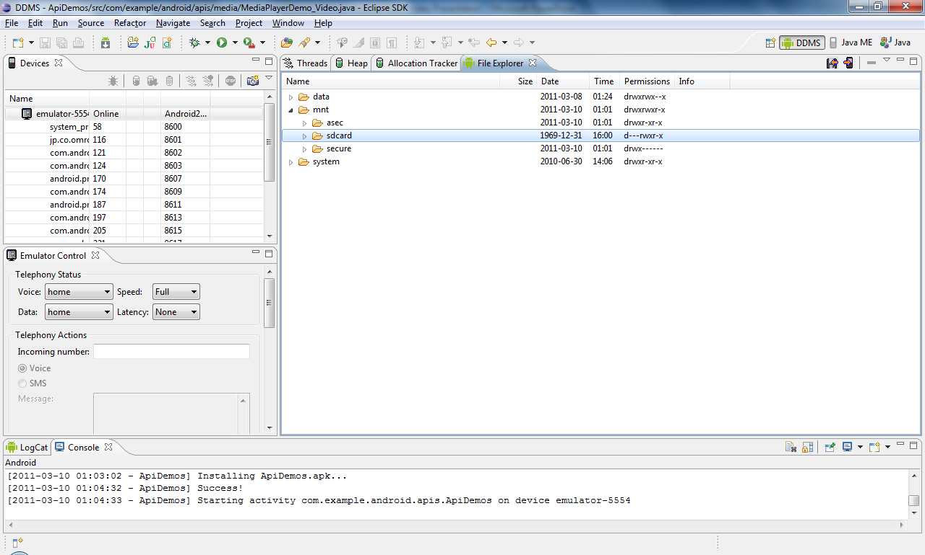

1. To load an mp3 file onto the emulator’s SD Card, click on the button under DDMS showing a phone with an arrow and select the file you want to load.

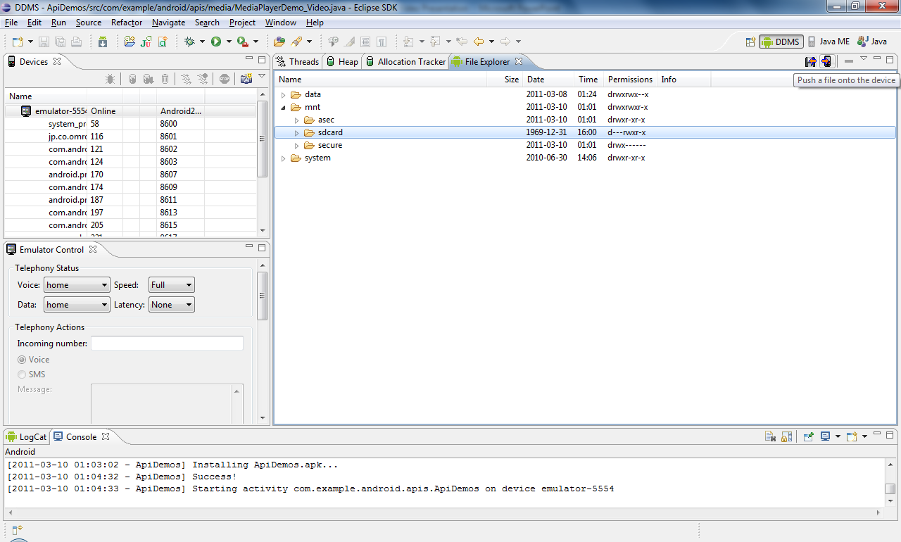

1. Now open **MediaPlayerDemo_Audio.java** in the package *com.example.android.apis.media* and enter the mp3 file name under the comment:

**case** *LOCAL_AUDIO*:

/**

* **TODO**: Set the path variable to a local audio file path.

*/

path = "/mnt/sdcard/<filename>.mp3";

1. Create a **LinearLayout** object and initialize it in the **onCreate** method. Modify the **setContentView(tx)** in the **onCreate** method to **setContentView(LinearLayout linear)**
2. Create a button each for ‘**Pausing**’, ‘**Rewinding**’, and ‘**Forwarding**.’
3. Add the TextView **tx** and the three buttons your created to the LinearLayout.

@Override

**public** **void** onCreate(Bundle icicle)

{

**super**.onCreate(icicle);

linear = **new** LinearLayout(**this**);

linear.setOrientation(LinearLayout.*VERTICAL*);

tx = **new** TextView(**this**);

btnPause = **new** Button(**this**);

btnPause.setText("Pause");

btnPause.setOnClickListener(**this**);

btnForward = **new** Button(**this**);

btnForward.setText("Forward");

btnForward.setOnClickListener(**this**);

btnRewind = **new** Button(**this**);

btnRewind.setText("Rewind");

btnRewind.setOnClickListener(**this**);

linear.addView(tx);

linear.addView(btnPause);

linear.addView(btnForward);

linear.addView(btnRewind);

setContentView(linear);

Bundle extras = getIntent().getExtras();

playAudio(extras.getInt(*MEDIA*));

}

1. Implement and set the **OnClickListener** for the three buttons. Use the methods **pause()** and **seekTo(int msec)** for pausing, rewinding and fast-forwarding. The pause button should change to a play button when the file is already in paused state. Also display the current position of the file and the total duration of the file.

@Override

**public** **void** onClick(View v)

{

**if**(v==btnPause)

{

**if**(mMediaPlayer.isPlaying())

{

mMediaPlayer.pause();

btnPause.setText("Play");

tx.setText("Playing audio: " +

mMediaPlayer.getCurrentPosition()

+ " of " + mMediaPlayer.getDuration());

}

**else**

{

mMediaPlayer.start();

btnPause.setText("Pause");

}

}

**if**(v==btnForward)

{

**if**(mMediaPlayer.isPlaying()

&& ((mMediaPlayer.getCurrentPosition() + 2000) <

mMediaPlayer.getDuration()))

{

mMediaPlayer.seekTo(mMediaPlayer.getCurrentPosition() +

2000);

tx.setText("Playing audio: " +

mMediaPlayer.getCurrentPosition()

+ " of " + mMediaPlayer.getDuration());

}

}

**if**(v==btnRewind)

{

**if**(mMediaPlayer.isPlaying()

&& ((mMediaPlayer.getCurrentPosition() - 2000) > 0))

{

mMediaPlayer.seekTo(mMediaPlayer.getCurrentPosition() –

2000);

tx.setText("Playing audio: " +

mMediaPlayer.getCurrentPosition()

+ " of " + mMediaPlayer.getDuration()); }

**else**

{

mMediaPlayer.seekTo(0);

tx.setText("Playing audio: " +

mMediaPlayer.getCurrentPosition()

+ " of " + mMediaPlayer.getDuration());

}

}

}

1. Rerun the APIDemos application in the emulator and try playing the mp3 file you loaded to the emulator’s SD Card.

**Part 2: Video Player**

1. Load a 3gp or mp4 video file to the emulator’s SD Card (3gp files can be downloaded at <http://www.free-3gp-video.com/>)
2. Open the file **MediaPlayerDemo_Video.java** in the *com.example.android.apis.media* package. Enter the video filename under the comment:

**case** *LOCAL_VIDEO*:

/*

* **TODO**: Set the path variable to a local media file path.

*/

path = "/mnt/sdcard/<filename>.3gp";

1. Now enter a http 3gp video stream path under the comment:

**case** *STREAM_VIDEO*:

/*

* **TODO**: Set path variable to progressive streamable mp4 or

* 3gpp format URL. Http protocol should be used.

* Mediaplayer can only play "progressive streamable

* contents" which basically means: 1. the movie atom has to

* precede all the media data atoms. 2. The clip has to be

* reasonably interleaved.

*

*/

path = "<http://...>";

3gp streams can be found at: <http://www.zoovision.com/mobile.html>

1. Rerun the APIDemos application in the emulator and try playing the local and streaming videos. Try playing the videos on an actual Android phone if available.